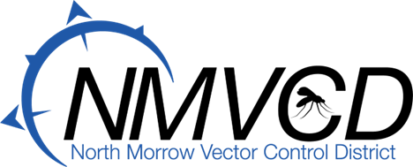
6-28-2023
Budget Hearing
Meeting Minutes

Time: 6:30 PM the NMVCD Budget Committee Meeting was called to order by Board Chairman Glenn Maret on June 28th, 2023.

Members Present:
Glenn Maret, (Board Chairman) Pat Tolar, (Board member)
Smokey Joe Wightman, (Board Member) Lenn Greer (Board Member)
Kevin Gilbertson (Board Member)
Greg Barron, (Budget Officer)
Anita Baumgart, (Acting Secretary)

Budget Committee Meeting was respectfully turned over to Budget Officer, Greg Barron.

Minutes Approval: Pat Tolar moved to approve the minutes, Smokey Joe Wightman seconded. Motion passed.

2023-24 Budget Approval: Smokey Joe Wightman moved to approve the 2023-24 Operation Budget. Kevin Gilbertson seconded. Motion passed. Resolution Adopting the Budget No. 2023-24 for the Total Adopted Budget amount of $2,218,484 was adopted by the Board of Trustees and signed by the Board Chairman Glenn Maret.

Mosquito Update: We hired all but one of our summer Mosquito Technicians. The Aedes Vexans and Dorsalis population exploded mostly in the Irrigon area in May, but eventually because of the North breezes found their way downstream to the Boardman area along the river by Mother’s Day weekend. The main reason for this is because the river was up. On Wednesday May 29th we flew the Irrigon area utilizing VDCI, our aerial adult mosquito control contingency contractor, with excellent results. We sprayed over 5,000 acres. All sources in our district have been treated and will continue to be treat with larvicide via helicopter throughout the season. Even though we are shorthanded and training new employees we are getting the job done. This week we have noticed a decrease in the river water elevation which will mean less larval breeding sources on the Washington State side of the river.

Currently, we are all out in the field surveying mosquito populations and treating with larvicides. Ashley our adult mosquito surveillance technician, has been busy training new employees, trapping, counting, identifying, and pooling mosquitoes for testing at the Oregon State University Veterinary Diagnostic Laboratory. We have been fogging for adult mosquitoes on a routine basis.

Meeting Adjourned: Lenn Greer move to adjourn the meeting. Seconded by Pat Tolar. Meeting was adjourned at 7:45.

Respectfully Submitted by:
Anita M. Baumgart, Acting Secretary

