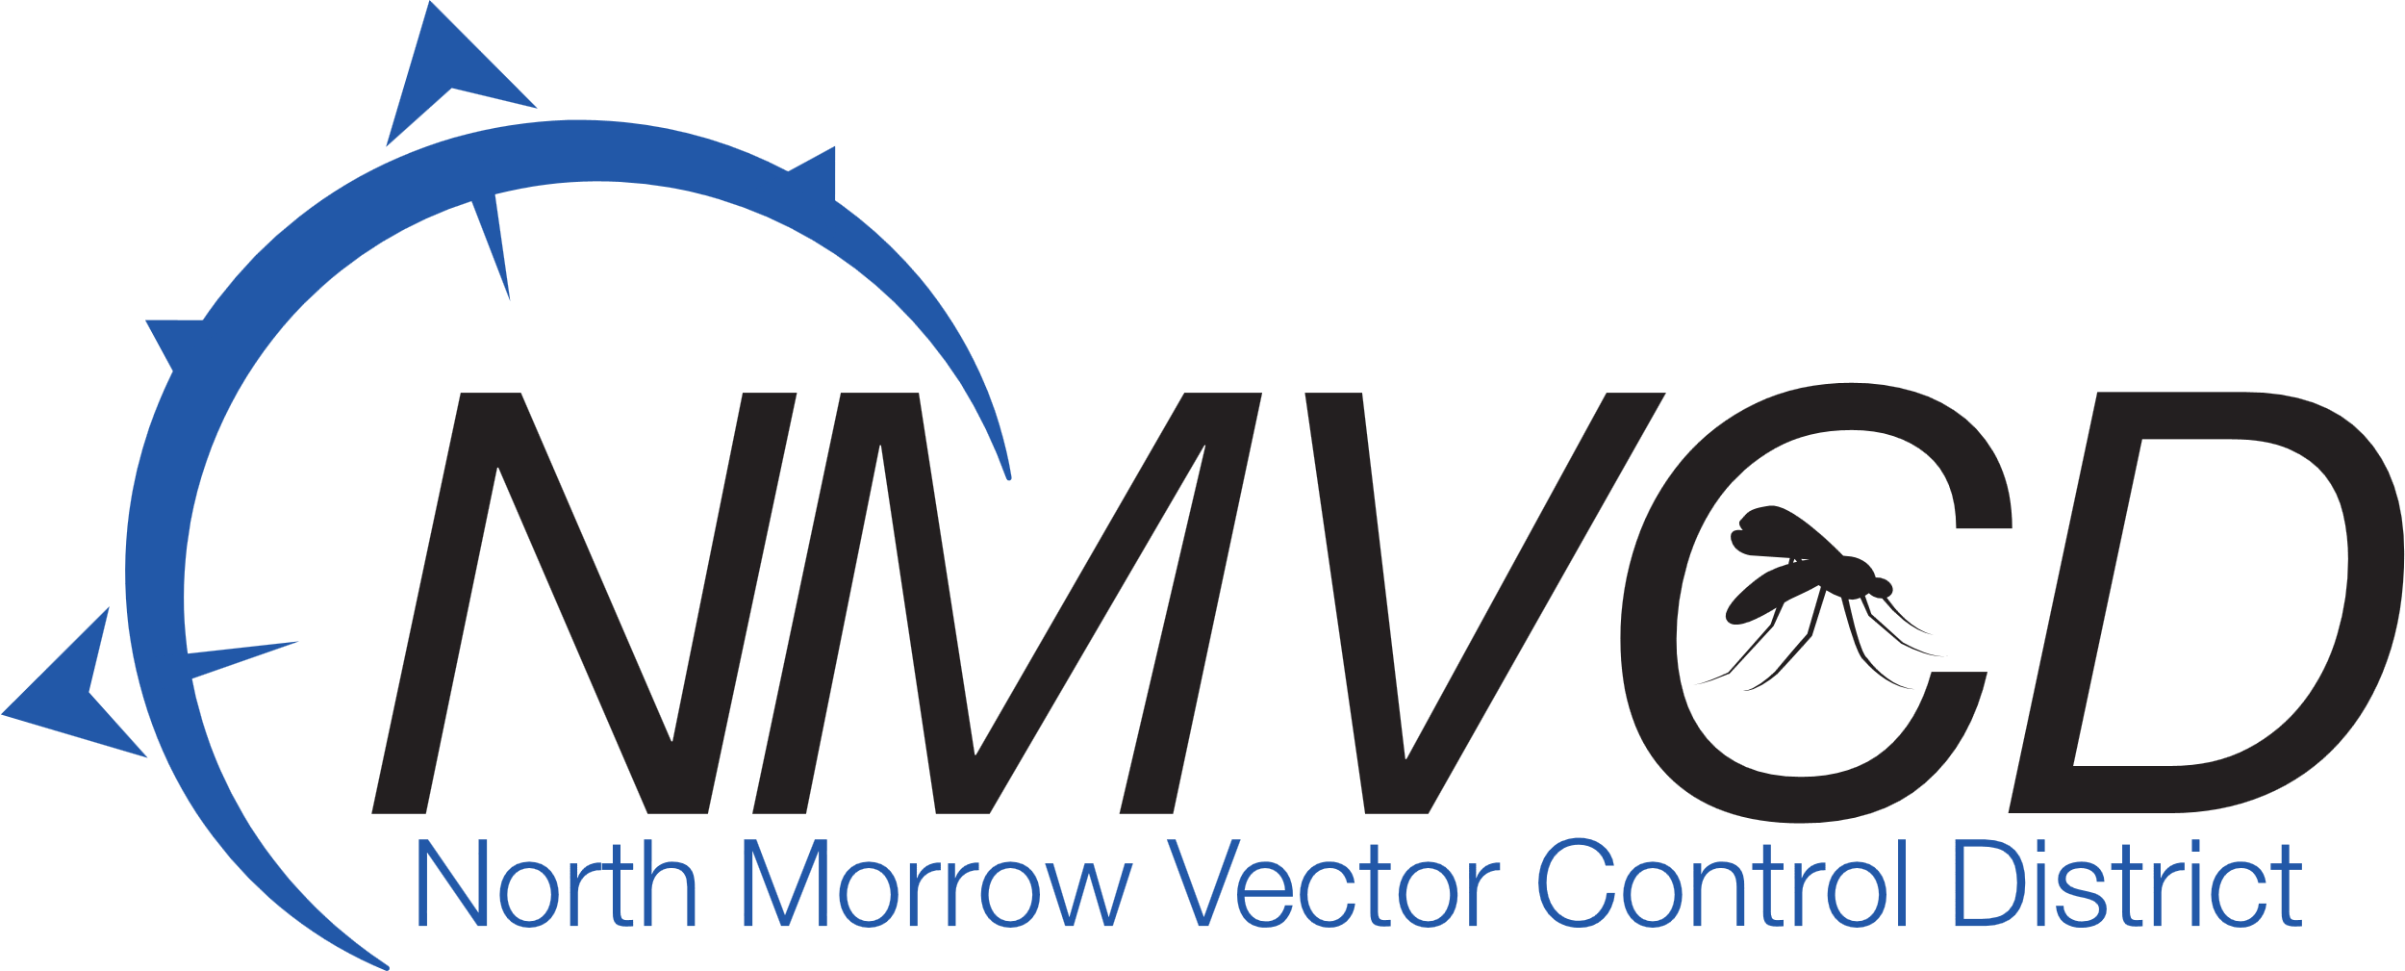
“We bite mosquitoes back!”
North Morrow Vector Control District
5/22/2024
NMVCD Office
Budget Committee Meeting

IN ATTENDANCE: Glenn Maret, Board Chairman: Greg Barron, Budget Officer: Anita Baumgart, Acting Secretary: Members: Pat Tolar, Smokey Joe Wightman, Kevin Gilbertson, Loren Dieter, Jake Case, Lizette Peña Absent: Lenn Greer, Laura Combes and Brian Mendoza
A Quorum was established.
The Meeting was called to order at 6:48pm by Chairman Glenn Maret.

Board Action: (Tolar/Gilbertson) Motion to accept the minutes from the board meeting on April 24,2024
7 in favor/0 opposed/0 abstention. Motion Carries

Budget Officer Report
Greg Barron, Budget officer presented the proposed 2024-25 by line item. Discussion on salaries ensued. Kevin Gilbertson explained to new members how Greg and Anita’s salaries are compared with other mosquito districts to ensure that NMVCD salaries are competitive with other districts.
Greg also discussed the proposed Option Levy. The Option Levy will be discussed further and finalized at the Budget Hearing on June 26th.

Board Action: (Dieter/Tolar) Motion to approve the proposed 2024-25 budget as submitted by Greg Barron, Budget officer.
7 in favor/0 opposed/0 abstention. Motion Carries

Mosquito Control Update: Anita Baumgart gave an update on how the mosquito season has started off slowly but is beginning to pick up since the Columbia River water levels have risen. River water Levels are predicted to remain high until the end of June and with that more biting aedes mosquitoes migrating across the river to inundate the Irrigon and Boardman shorelines.
Future of the Vector Control Building Update: Greg Barron stated that the district financials have been approved by Banner Bank for a possible municipal construction loan. Land for the new site is still in the works.
Good of The Order: At the last board meeting discussion ensued about the district’s money in the bank being adequately insured. Greg Barron was to check into the matter and report back to the Board. Greg Barron contacted Banner Bank and confirmed that the district’s money is safely FDIC insured because we invest in the Public Funds Collateralization Program through the Oregon State Treasury.
Next Budget Committee Hearing: June 26th, 2024. 6:30 pm.
Board Action: (Wightman/Dieter) To adjourn meeting at 8:05 pm.
7 in favor/0 opposed/0 abstention. Motion Carries

Respectfully submitted by:
Anita Baumgart, Acting secretary

Email: gbarron@centurytel.net
Website: nmvector.org

Gregory Barron, Manager
P.O. Box 192
3 NE Marine Drive
Boardman, OR. 97818
Phone: 541.481.6082

