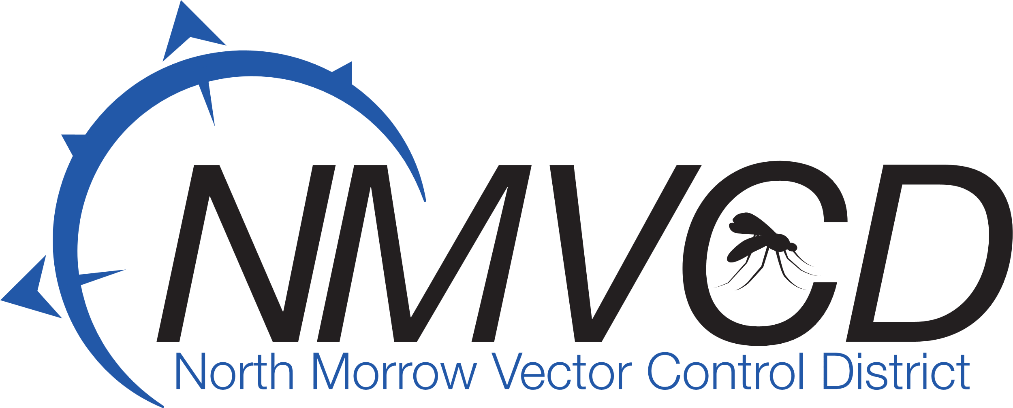
“We Bite Mosquitoes Back!”
Gregory Barron, Manager
P.O. Box 192
3 NE Marine Drive
Boardman, OR. 97818
Phone: 541.481.6082

Email: gbarron@centurytel.net
Website: nmvector.org

North Morrow Vector Control District
6/26/2024
Budget Hearing Meeting Minutes

IN ATTENDANCE: Glenn Maret, Board Chairman: Greg Barron, Budget Officer: Anita Baumgart, Acting Secretary: Members: Pat Tolar, Smokey Joe Wightman, Lenn Greer and Kevin Gilbertson
A Quorum was established.
The Meeting was called to order at 6:30 pm by Board Chairman Glenn Maret.

Board Action: (Greer/Tolar) Motion to accept the minutes from the budget committee meeting on May 22,2024.
5 in favor/0 opposed/0 abstention. Motion Carries

Board Action: (Greer/Tolar) Motion to approve the proposed operational 2024-25 budget as submitted by Greg Barron, Budget officer. Resolution Adopting the Budget was approved and signed.
5 in favor/0 opposed/0 abstention. Motion Carries

Board Action: (Greer Wightman) Motion to impose an Option Levy in the amount of $.10 per $1,000 of assessed value for mosquito control operations for four years beginning in 2025-26. Resolution to authorize the Option Levy was approved and signed.

5 in favor/0 opposed/0 abstention. Motion carries

Discussion: Greg Barron proposed to raise the current capital item Board approval for capital item purchases minimum from $5,000 to $15,000.

Board Action: (Wightman/Tolar) Motion to approve an increase in the capital Item purchases minimum from $5,000 to $15,000.
5 in favor/0 opposed/0 abstention. Motion Carries

Discussion: Greg proposed to the board that the district approve a Mastercard through Banner Bank and increase the limit to $25,000. Greg explained that this would directly link our company credit card to our Banner Bank account and make purchases and billing much more streamlined. Gregory Barron, Manager and Anita Baumgart, Surveillance Supervisor would be authorized to use and issued MasterCard’s through Banner Bank.

Board Action: (Greer/Tolar) Motion to approve obtaining a Mastercard through Banner Bank with a limit of $25,000.
5 in favor/0 opposed/0 abstention. Motion Carries

Future of the Vector Control and Project Funding Update: Greg brought the board up to date regarding the “land swap” deal with the Port of Morrow and how the Port is going to deed us property and then take over our buildings at our current location. The proposed location sites are Junction Ponds, east of the transfer station, Patterson Ferry Rd on the east corner next to I-84 and the Collins site on Pole line Rd at the old sawmill site. Greg stated he has emailed Jeff Wenholz about possible American Rescue Plan Act (Covid Money) and a 0% interest NEPA loan through Umatilla Electric Cooperative Association for up to $360,000 for individual projects within our construction project with a 10-year payback. Greg also has an email to Matt Jenson, the county administrator, about possible money from the county for projects specific to our request. Greg will report back to the board at the next meeting with his findings.
Greg has been in correspondence with Walter Timmons, Relationship Manager with the Banner Bank Columbia Basin Commercial Banking Center regarding a construction loan for this project. Walter has been reviewing our district financials and will get back with us soon.

Mosquito Update: Anita informed the board that the mosquito season is going well, with fewer mosquito numbers being captured by our adult EVS traps. The mosquitoes are starting to transition from the daytime biters (aedes) to the disease transmitting (culex). All in all, the season is looking good. Now we wait for August and September to arrive. The forecast is for 100-degree days next week.

Board Action: (Wightman/Greer) motion to adjourn meeting at 7:55 pm.
5 in favor/0 opposed/0 abstention. Motion Carries
Respectfully submitted by:
Anita Baumgart, Acting secretary

