Budget Hearing Agenda

1) Read and Approve Minutes from Budget Committee Meeting

2) Discuss and approve 2024-25 Proposed Operational Budget

3) Option Levy

4) Sign Resolutions

5) Capital Outlay Item $15,000 Minimum for Approval

6) Banner Bank Mastercard

7) Land Swap between NMVCD and POM and Funding

8) Mosquito Control Update

Respectfully,
Greg Barron,
Budget Officer
gbarron@centurytel.net
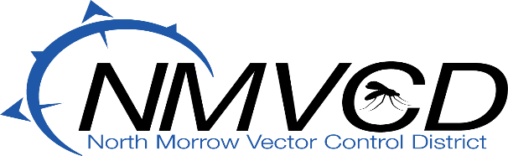

3 Marine Drive/ P.O. Box 192 Boardman, OR 97818
Telephone (541) 481-6082
Email gbarron@centurytel.net
Website nmvector.org

