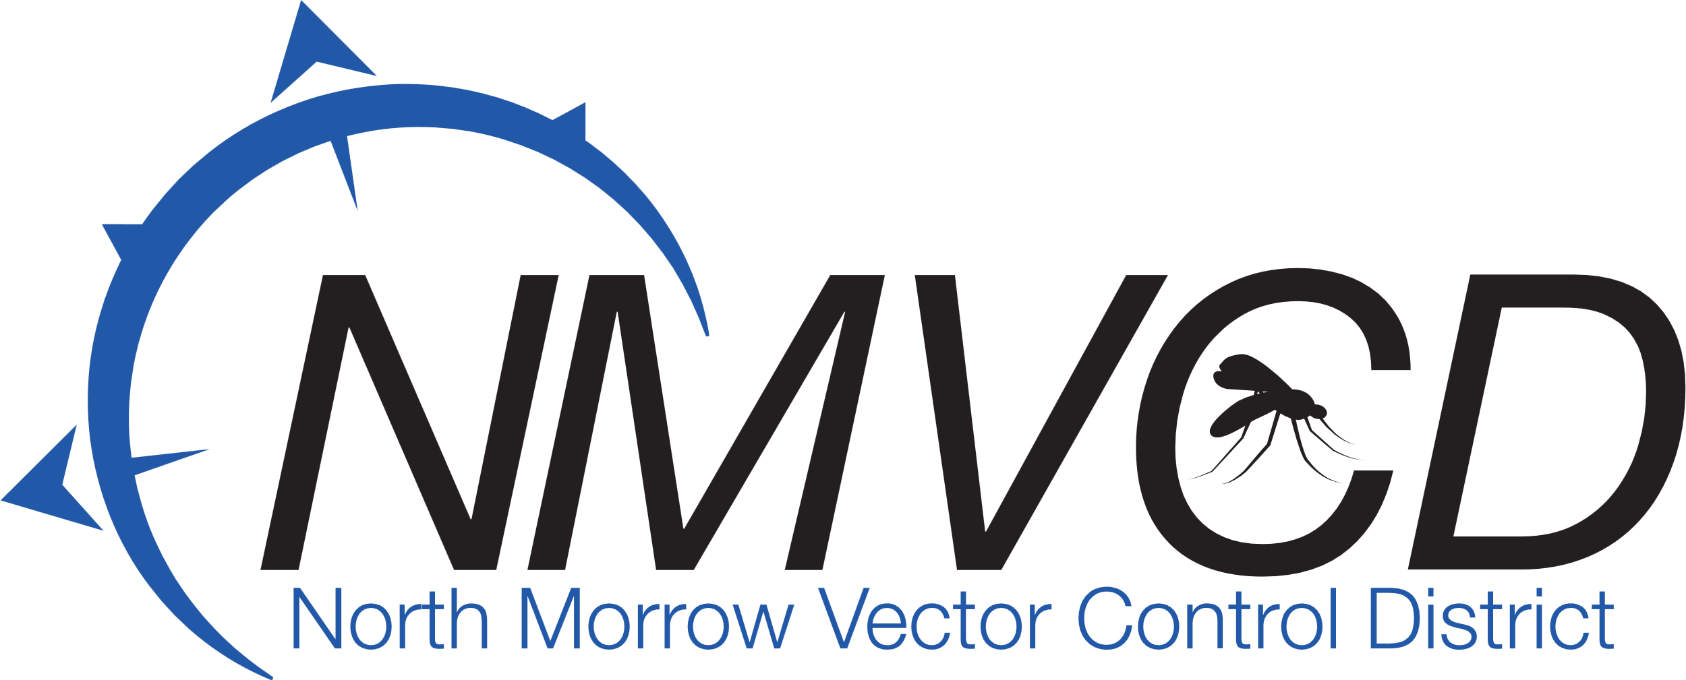
“We bite mosque

Gregory Barron, Manager
P.O. Box 192
3 NE Marine Drive
Boardman, OR. 97818
Phone: 541.481.6082

NORTH MORROW VECTOR CONTROL DISTRICT
Budget Committee Meeting Minutes
Date: May 20, 2026
Time: 6:33 PM – 8:05 PM
Location: NMVCD Office

I. Call to Order & Roll Call
Chairman Glenn Maret called the meeting to order at 6:33 PM. A quorum was officially established.
Committee Members in Attendance:
- Glenn Maret, Board Chairman
- Greg Barron, Budget Officer
- Anita Baumgart, Acting Secretary
- Pat Tolar, Committee Member
- Smokey Joe Wightman, Committee Member
- Jake Case, Committee Member
- Loren Dieter, Committee Member
- Robert Purves, Committee Member
- Dan Daltoso, Committee Member
Members Absent:
- Lizette Pena
- Laura Combes
- Kevin Gilbertson

II. Approval of Minutes
- Motion: Moved by Pat Tolar and seconded by Smokey Joe Wightman to approve the minutes of the April 30th, 2026, Board Meeting.
- Discussion: None.
- Vote: Motion Passed Unanimously (7-0-0)
  - Ayes: Maret, Tolar, Wightman, Case, Dieter, Purves, Daltoso.
  - Nays: None. Absentees: None.

III. Budget Officer Report
Budget Officer Greg Barron presented the proposed Fiscal Year 2026–27 General Operating Budget and Capital Project budgets line item by line item. Copies of the proposed budget document were distributed and reviewed by the committee.

IV. Board & Committee Actions

Motion 1: FY 2026–27 General Operating Budget Approval
- Motion: Moved by Smokey Joe Wightman and seconded by Pat Tolar to approve the proposed FY 2026–27 General Operating Budget as submitted by Budget Officer Greg Barron.
- Discussion: None.
- Vote: Motion passed unanimously (7–0–0).
  - Ayes: Maret, Tolar, Wightman, Case, Dieter, Purves, Daltoso.
  - Nays: None. Abstentions: None

Motion 2: Capital Project Budgets Adoption
- Motion: Moved by Smokey Joe Wightman and seconded by Pat Tolar to adopt both Capital Project budgets as presented:
  - Capital Project Budget (1): As written by David Ulbricht, SDAO Advisory Services.
  - Capital Project Budget (2): As written by Mindy Davis, Auditor at CPA Connected.
The motion was made with the explicit understanding that the Board and Budget Committee will be kept informed as additional information is gathered, allowing for future adjustments to be proposed and voted upon as necessary.
- Discussion: Minor committee discussion ensued regarding the flexibility and mechanism of making future adjustments as updated project data becomes available.
- Vote: Motion carried (6–1–0).
  - Ayes: Glenn Maret, Pat Tolar, Smokey Joe Wightman, Jake Case, Robert Purves, Dan Daltoso.
  - Nays: Loren Dieter.
  - Abstentions: None.
  - Nays: None. Abstentions: None.

V. Operational & Project Updates

Mosquito Control Update
Greg Barron provided an operational update regarding seasonal mosquito control efforts:
- Trapping: Field trapping started earlier this season to gather comprehensive field data. This early data has guided successful fogging operations in areas even where public requests have not yet been logged.
- Aviation: The helicopter has completed two flights to date. During the second flight, a long-term control product was applied to preemptively manage population growth on the Oregon side of the Columbia River in the event the helicopter faces a two-week delay returning.
- River Conditions: The Columbia River levels remain expectedly high for this time of year. General public requests for fogging are beginning to trickle in.

Vector Control Building Facility Update
The committee reviewed the status of the building facility procurement process:
- Bids have been formally issued, resulting in several inquiries from general contractors.
- The committee discussed the desired scope of completion (turn-key vs. basic finishes like flooring and lock installations).
- Consensus: The committee agreed to omit automatic electronic doors from the immediate project scope but directed that electrical wiring be "roughed-in" to the door locations to accommodate future electronic upgrades easily.

VI. Next Meeting
The next Budget Committee Hearing is scheduled for June 17, 2026, at 6:30 PM at the NMVCD Office.

VII. Adjournment
- Motion: Moved by Jake Case and seconded by Pat Tolar to adjourn the meeting.
- Vote: Motion passed unanimously (7–0–0).
  - Ayes: Maret, Tolar, Wightman, Case, Dieter, Purves, Daltoso.
The meeting was officially adjourned at 8:05 PM.
Submitted by: ____________________________
Anita Baumgart, Acting Secretary
Approved by: ____________________________
Glenn Maret, Board Chairman
Email: gbarron@centurytel.net
Website: nmvector.org

