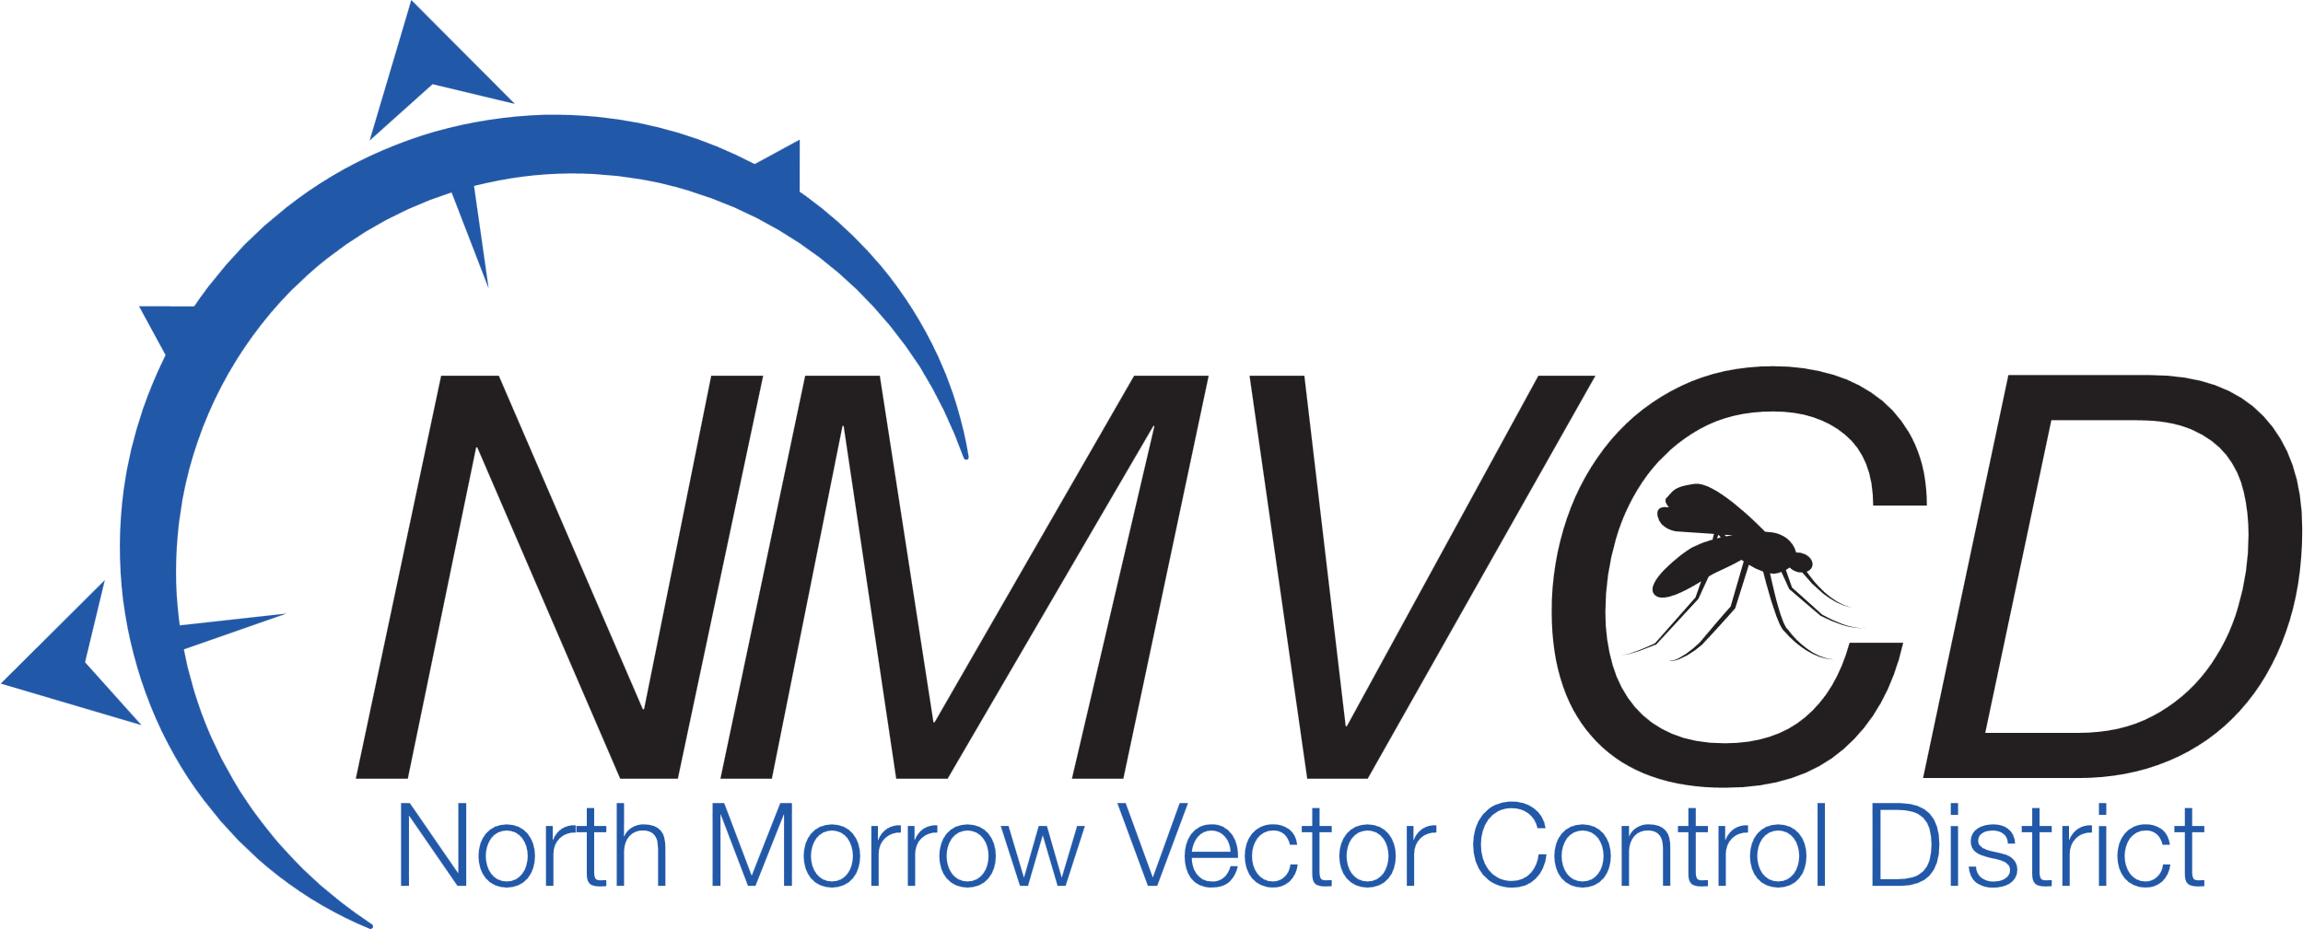“We bite mosquitoes back!”

**North Morrow Vector Control District**

**5/21/2025**

**NMVCD Office**

**Budget Committee Meeting**

**IN ATTENDANCE:** Glenn Maret**, Board Chairman:** Greg Barron, **Budget Officer**: Anita Baumgart**, Acting Secretary**: **Members:** Pat Tolar, Smokey Joe Wightman, Loren Dieter, Jake Case, Laura Combes, Robert Purves **Absent:** Lizette Pena, Brian Mendoza, Kevin Gilbertson

A Quorum was established.

The Meeting was called to order at 6:33 pm by Chairman Glenn Maret.

**Sign Oath of Office:**  Jake Case and Smokey Joe signed the Oath of Office. Jake Case will be replacing former board member Lenn Greer.

**Budget Officer Report:**

Greg Barron, Budget officer presented the proposed 2025-26 budget line item by line item.

**Board Action:** (Dieter/Case) Motion to approve the proposed 2025-26 budget as submitted by Greg Barron, Budget officer.

Seven in favor/0 opposed/0 abstention. Motion Carries

**Board Action:** (Tolar/Wightman) Motion to approve the renewal of the 3-year $60,000 line of credit.

Seven in favor/0 opposed/0 abstention. Motion Carries

**Mosquito Control Update:** Anita Baumgart’s mosquito update informed that the mosquito season has started off busier than last season, with more standing water being the cause. Some residents of Irrigon have water that has been standing on their property and under their homes, the cause is unknown but looks like it maybe a problem that persists in the future. As expected, the Columbia River water levels have risen and the migrating Washington mosquitoes have been making their way into the communities of Boardman and Irrigon, triggering the district to fog for adult mosquitoes.

**Vector Control Relocation Update:** The Port of Morrow and North Morrow Vector Control District has agreed upon a new location site for the district. The Port is in the process of preparing the paperwork for the land swap.

**Next Budget Committee Hearing:** June 11th, 2025. 6:30 pm.

**Board Action:** (Case/Tolar) To adjourn meeting at 7:55 pm.

Seven in favor/0 opposed/0 abstention. Motion Carries

**Respectfully submitted by:**

**Anita Baumgart, Acting secretary.**

Email: [gbarron@centurytel.net](mailto:gbarron@centurytel.net)

Website: nmvector.org

Gregory Barron, Manager

P.O. Box 192

3 NE Marine Drive

Boardman, OR. 97818

Phone: 541.481.6082