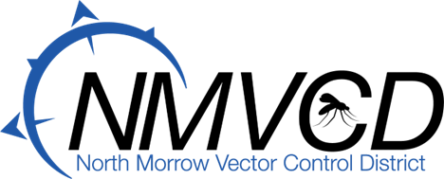
6-29-2022
Budget Hearing
Meeting Minutes

Time: 6:30 PM the NMVCD Budget Committee Meeting was called to order by Board Chairman Glenn Maret on June 29th, 2022.

Members Present:
Glenn Maret, (Board Chairman) Pat Tolar, (Board member)
Smokey Joe Wightman, (Board Member)
Greg Barron, (Budget Officer)
Anita Baumgart, (Acting Secretary)

Members Absent:
Lenn Greer (Board Member)
Kevin Gilbertson (Board Member)

Budget Committee Meeting was respectfully turned over to Budget Officer, Greg Barron.

Minutes Approval: Pat Tolar moved to approve the minutes, Smokey Joe Wightman seconded. Motion passed.

2022-2023 Budget Approval: Budget Officer, Greg Barron discussed the changes that were made to the budget as amended at the May Budget Meeting. Smokey Joe Wightman moved to approve the 2022-2023 Operation Budget. Glenn Maret seconded. Motion passed. Resolution Adopting the Budget No. 2022-23 for the Total Adopted Budget amount of $1,738,929 was adopted and signed by the Board Chairman Glenn Maret.

Mosquito Update: We finally hired all of our summer Mosquito Technicians. The Culiseta inornata population exploded mostly in the Irrigon area in June. The main reason for this is because the helicopter was out for repairs for 4 weeks and the river is up. On Sunday June 26th we flew the Irrigon area utilizing VDCI our aerial adult mosquito control contingency contractor with excellent results. We sprayed over 5,000 acres. We finally flew larvicide on our sources via the helicopter Wednesday June 29th.

Currently, we are all out in the field surveying mosquito populations and treating with larvicides. Ashley our adult mosquito surveillance technician trapping, counting, identifying, and pooling mosquitoes for testing at the Oregon State University Veterinary Diagnostic Laboratory. We have been fogging for adult mosquitoes on a routine basis.

Meeting Adjourned: Glenn Maret move to adjourn the meeting. Seconded by Pat Tolar. Meeting was adjourned at 7:45.

Respectfully Submitted by:
Anita M. Baumgart, Acting Secretary

