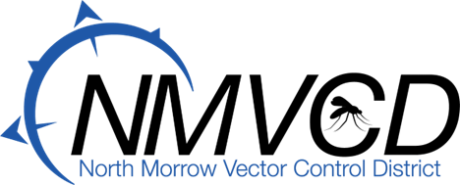
5-25-2022
Budget Committee
Meeting Minutes

Time: 6:50 PM the NMVCD Budget Committee Meeting was called to order by Board Chairman Glenn Maret on May 25th, 2022.

Members Present:
Glenn Maret, (Board Chairman) Pat Tolar, (Board member)
Smokey Joe Wightman, (Board Member) Kevin Gilbertson, (Board Treasurer)
Lenn Greer, (Board member) Greg Barron, (Budget Officer)
Anita Baumgart, (Acting Secretary)

Budget Committee Meeting was respectfully turned over to Budget Officer, Greg Barron.

Minutes Approval: Kevin Gilbertson moved to approve the minutes, Pat Tolar seconded. Motion passed.

Mosquito Control Update: Greg updated the group about the challenges of hiring people to work. Greg stated that we have been flying the helicopter and have been out in the field. We have three employees returning and need to hire at least two more employees.

Short Term Credit Discussion: About continuing the $60,000.00 Short Term Credit Loan thru Banner Bank ensued.

Banner Bank Short Term Note Motion: Kevin Gilbertson moved to continue the $60,000.00 Short Term Note in the budget thru Banner Bank. Lenn Greer Seconded the motion. Motion Passed. Glenn Maret, Board Chairman, Kevin Gilbertson, Board Treasurer and Greg Barron, Manager will be signers on the note representing North Morrow Vector Control District.

Field Technician Discussion: About Field Technician wages ensued. It was decided to increase the Field Technician budgeted line item by $10,000.00. this means that a Field Technician starting wage will begin at $16.00 per hour, and after obtaining the required Public Applicators License the wage will increase to $18.00 per hour.

2022-2023 Budget Approval: After some discussion Lenn Greer moved to approve the budget as amended. Pat Tolar seconded. Motion passed.

County Treasurer Motion: to authorize the County Treasurer to invest the funds of NMVCD for the fiscal year 2022-2023 was made by Lenn Greer. Seconded by Smokey Joe Wightman. Motion passed and was signed.

Drone Upgrade Motion: to authorize the purchase of the PV-35 for $44,420.00 from Leading Edge Technology, Inc was made by Lenn Greer. Seconded by Kevin Gilbertson. Motion passed.

Meeting Adjourned: Glenn Maret move to adjourn the meeting. Seconded by Pat Tolar. Meeting was adjourned at 7:45.

Respectfully,
Anita Baumgart, Secretary

