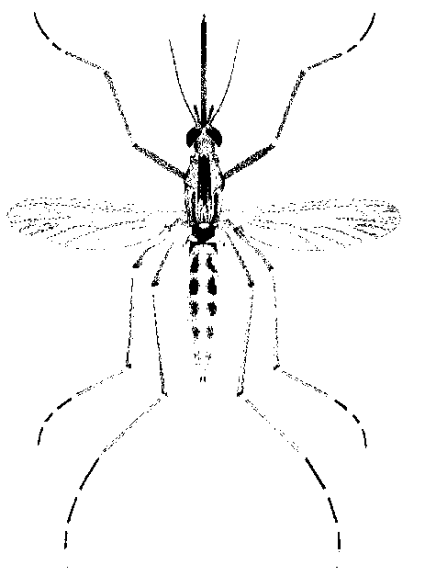
North Morrow Vector Control District
P.O. Box 192 / 3 Marine Drive
Boardman, OR 97818
541.481.6082 Voice / 541.481.6082 Fax (By Request)
gbarron@centurytel.net

Budget Committee Meeting Agenda:
May 21, 2025 / 6:30 pm / 3 Marine Dr.NE

- Approve the last Board Meeting Minutes

- Discusses and approve proposed FY 2025-26 Operating Budget

- Mosquito control update

- Future of Vector Control: relocation update

- Good of the order

- Budget Hearing meeting date

Respectfully,

Greg Barron, Manager & Budget Officer
gbarron@centurytel.net
Website: nmvector.org
(541) 481-6082

