Budget Hearing Agenda

1) Read and Approve Minutes from Budget Committee Meeting

2) Discuss and approve 2025-26 Proposed Operational Budget

3) Sign Resolutions

4) Land Swap between NMVCD and POM and Funding

5) Mosquito Control Update

Respectfully,
Greg Barron,
Budget Officer
gbarron@centurytel.net
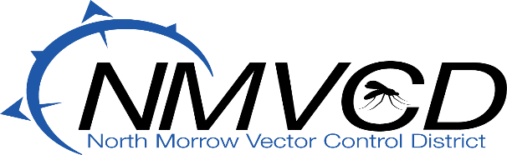

3 Marine Drive/ P.O. Box 192 Boardman, OR 97818
Telephone (541) 481-6082
Email gbarron@centurytel.net
Website nmvector.org

