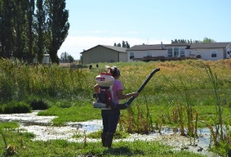
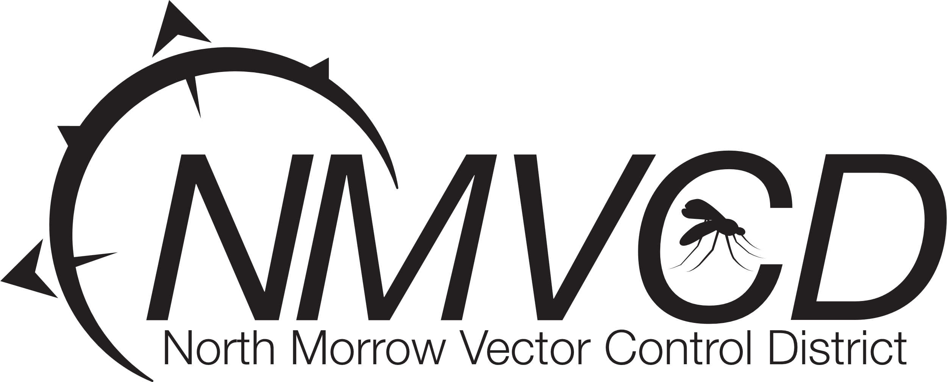
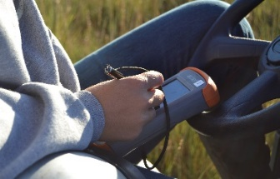
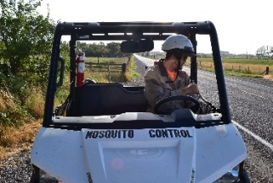

Vector Surveillance & Public Health Internship

North Morrow Vector Control District | Boardman, OR Pay: $18.00 - $20.00/hr. | Schedule: 4/10s (Mon–Thu) | Seasonal: May – October
The Opportunity Are you looking for a summer role that combines field biology, precision technology, and public service? The North Morrow Vector Control District is seeking motivated individuals to join our team as Vector Surveillance Technicians. This is a premier opportunity for students in Agriculture, Biology, or Applied Sciences to gain hands-on experience in public health and environmental management.
Why This Internship?
- Resume Builder: Gain specialized field experience in disease surveillance and pest management.
- Technical Training: helicopters, ATVs, and advanced ULV (Ultra Low Volume) equipment.
- Professional Certification: We provide the training and resources to help you earn your Oregon Public Pesticide Applicator license, resulting in an immediate pay increase to $20.00/hr.
- The Schedule: Our 4-day, 10-hour work week gives you 3-day weekends all summer long.
Key Responsibilities * Biological Surveillance: Survey diverse habitats (pastures, marshes, and waterways) to identify mosquito larvae and determine precise treatment methods.
- Data Collection: Use digital devices to maintain accurate records of field activities and mosquito populations.
- Field Operations: Safely operate trucks, ATVs, and hand-spray equipment.
- Aerial Support: Assist in ground-support operations for drone and helicopter applications.
- Laboratory Prep: Collect and identify adult mosquito species and prepare samples (including West Nile Virus testing) for PCR analysis.
- Community Engagement: Act as a professional representative of the district when responding to citizen requests.
Qualifications * Age/License: Must be at least 18 years old with a valid driver’s license.
- Physical Ability: Must be comfortable working outdoors in summer heat and able to lift 30–50 lbs. regularly.
- Professionalism: Strong communication skills and a respectful attitude toward the public and teammates.
- Drive: A self-motivated learner who can follow complex safety and technical directions.

How to Apply
We are currently accepting applications for the 2026 season! You can submit your application through any of the following methods:
- Online: at nmvector.org under EMPLOYMENT simply fill out the application and hit submit
- In Person: Pick up or drop off an application at our District Office:
  - Address: 3 Marine Drive NE, Boardman, OR 97818.
  - Location Note: We are in the blue building directly east of the Burnt Field Brewing establishment.
- Email: Send an email requesting an application from Gregory Barron, Manager at gbarron@nmvcd.org.
  - Please use the subject line: EMPLOYMENT APPLICATION – [Your Name].
Questions? Call us at (541)-481-6082. If we are in the field, please leave a message and we will return your call promptly.

