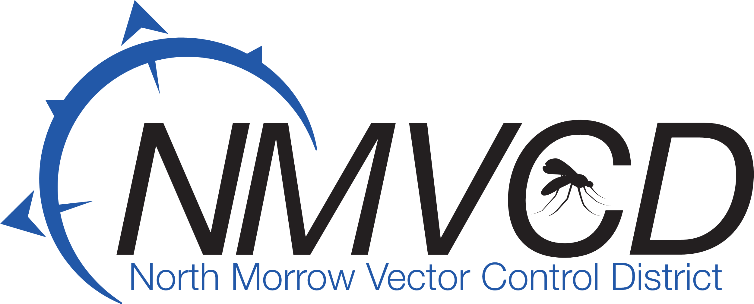
“We bite mosquitoes back!”

North Morrow Vector Control District
6/11/2025
District Office
Budget Hearing Meeting

IN ATTENDANCE: Glen Maret, Board Chairman: Greg Barron, Budget Officer: Anita Baumgart, Acting Secretary: Member: Pat Tolar, Smokey Joe Wightman, Jake Case, Kevin Gilbertson

A Quorum was established.
The Meeting was called to order at 6:35 pm by Chairman Glenn Maret.

Board Action: (Case/Wightman) Motion to approve the May 21, 2025, Budget Committee Minutes.

Seven in favor/0 opposed/ 0 abstention. Motion Carries

Board Action: (Gilbertson/Wightman) Motion to approve the proposed 2025-26 Operational budget as submitted by Greg Barron, Budget Officer.

Seven in favor/ 0 opposed/ 0 abstention. Motion Carries

Sign Resolutions: Resolution was signed by all members.

Land Swap between NMVCD and POM: No new updates to report. Greg will keep the Board Members informed as things start to move forward.

Mosquito Control Update: The Columbia River water level has dropped a few feet from 265 feet to 263.75. So, we should start to see a slow improvement with the mosquito numbers coming in from Washington State to our north. We are starting to transition from the Aedes mosquitoes (day biters) to the Culex mosquitoes (evening biters and disease transmitters).

Board Action: (Tolar/Case) To adjourn meeting at 8:05 pm.

Seven in favor/0 opposed/0 abstention. Motion Carries

Respectfully submitted by:

Anita Baumgart, Acting secretary.

Email: gbarron@centurytel.net
Website: nmvector.org

Gregory Barron, Manager
P.O. Box 192
3 NE Marine Drive
Boardman, OR. 97818
Phone: 541.481.6082

