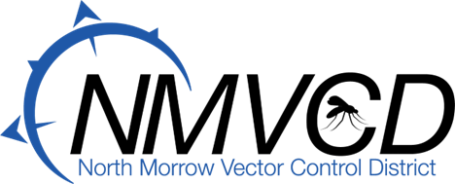
5-20-2026
Budget Committee
Meeting Agenda

Dear Budget Committee Members,

Our annual budget committee meeting to review the North Morrow Vector Control District’s proposed 2026-27 FY operating budget is scheduled for Wednesday, May 20, 2026, at 6:30 PM.

Meeting Agenda:

1) Approve the previous meeting minutes
2) Discuss and approve the proposed FY 2026-27 Operating Budget
3) Capital project review
4) Mosquito update
5) Good of the order
6) Set a date for the budget hearing

Gregory Barron
Greg Barron, Manager and Budget Officer
North Morrow Vector Control District
P.O. Box 192/ 3 Marine Drive NE
Boardman, OR. 97818
(541) 481-6082 (Office)
(541) 701-7311 (Cell)
gbarron@nmvcd.org

