

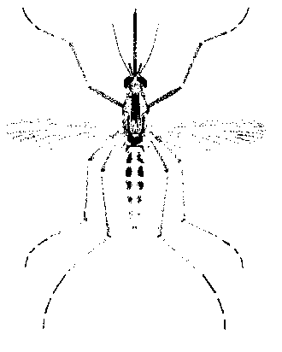
North Morrow Vector Control District
P.O. Box 192 / 3 Marine Drive
Boardman, OR 97818
541.481.6082 Voice / 541.481.6082 Fax
gbarron@centurytel.net

Morrow County Health Department
P.O. Box 799, Heppner, OR 97836
541.676.5421 Voice / 541.481.5652 Fax

Contact: Gregory A. Barron, Manager
North Morrow Vector Control District
541-481-6082

Sarah Rea Communicable Disease Coordinator,
Public Health Emergency Preparedness
Morrow County Health Department
541-676-5421

For Immediate Release:
7/20/2026

West Nile virus detected in mosquitoes in Morrow County

Boardman and Irrigon, Ore.—West Nile virus, which is spread by mosquitoes, has been detected in mosquitoes at three testing sites in Morrow County, Ore., according to Oregon Public Health officials.

Greg Barron, Manager of North Morrow Vector Control District said, “the mosquitoes found are the first to test positive for the disease in Morrow County in 2026.”

Health officials are advising people in Morrow County to take precautions against mosquitoes to avoid the risk of infection, including preventing mosquito bites. West Nile virus is spread to humans through the bite of an infected mosquito. Most infected people will show little or no signs of disease.

Communities and individuals living in or spending significant time outdoors, particularly near irrigated land, waterways, standing water, livestock watering troughs, ornamental ponds and used tires—including those working in agriculture, such as migrant and seasonal farm workers—may be at increased risk of mosquito bites and related diseases.

The virus also affects wildlife, domesticated and farm animals. Horses are a risk of developing West Nile Virus. Consult your veterinarian about vaccinating your horses against WNv.

“Although mosquitoes are an inevitable part of summer and fall, mosquito bites don’t have to be—they are preventable,” said Emilio DeBess, public health veterinarian. “You can take simple steps to protect yourself and reduce the risk of contracting West Nile disease.”

Dr. DeBess offers these tips for protecting yourself against mosquitoes:

- Eliminate sources of standing water that are a breeding ground for mosquitoes, including watering troughs, bird baths, ornamental ponds, buckets, wading and swimming pools not in use, and old tires.
- When engaged in outdoor activities at dusk and dawn when mosquitoes are most active, protect yourself by using mosquito repellants containing DEET, oil of lemon eucalyptus or Picardin, and follow the directions on the container.
- Wear long-sleeved shirts and long pants in mosquito-infested areas.
- Make sure screen doors and windows are in good repair and fit tightly.

Additional information about West Nile virus:

Oregon Health Authority website: http://public.health.oregon.gov/DiseasesConditions/DiseasesAZ/WestNileVirus/Pages/survey.aspx

U.S. Centers for Disease Control and Prevention:
http://www.cdc.gov/ncidod/dvbid/westnile/ index.htm

